1. <apex:page standardController="Account">

<apex:form >

<apex:pageBlock >

<apex:pageBlockButtons >

<apex:commandButton action="{!save}" value="Save"/>

</apex:pageBlockButtons>

<apex:pageBlockSection title="Account Information">

<apex:inputField value="{!Account.Name}"/>

<apex:inputField value="{!Account.AccountNumber}"/>

<apex:inputField value="{!Account.Rating}"/>

<apex:inputField value="{!Account.Industry}"/>

</apex:pageBlockSection>

<apex:pageBlockSection title="Category Information" >

<apex:inputField value="{!Account.Type}"/>

<apex:inputField value="{!Account.AnnualRevenue}"/>

</apex:pageBlockSection>

</apex:pageBlock>

</apex:form>

</apex:page>

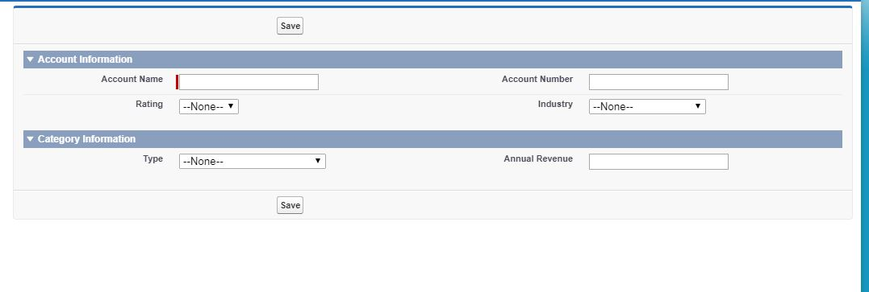

2. <apex:page standardController="Position__c" tabStyle="Position__c">

<apex:tabPanel >

<apex:tab title="Position Details" label="Position Details">

<apex:detail relatedList="false"/>

</apex:tab>

<apex:tab title="Job Application" label="Job Application">

<apex:relatedList subject="{!Position__c}" list="Job_applications__r"/>

</apex:tab>

<apex:tab title="Candidates" label="Candidates">

<apex:relatedList subject="{!Position__c}" list="Candidates__r"/>

</apex:tab>

</apex:tabPanel>

</apex:page>

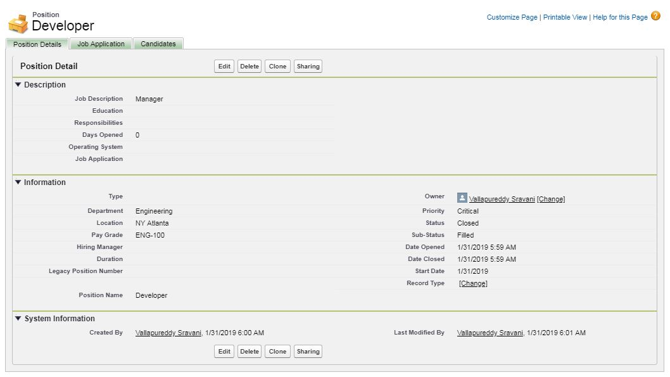

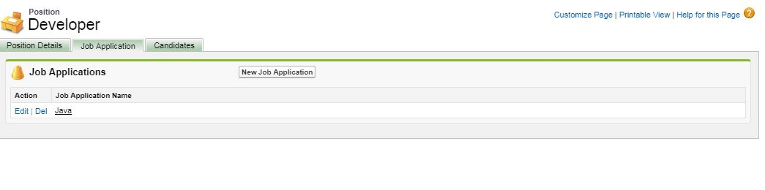

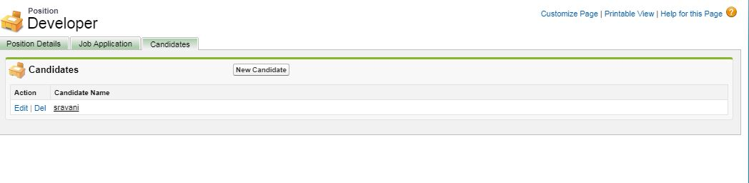

3.1

Course__c C1=new Course__c();

C1.APEX_Course_Name__c='Engineering';

C1.APEX_Credits__c=30;

insert(c1);

Course__c C2=new Course__c();

C2.APEX_Course_Name__c='Electrical';

C2.APEX_Credits__c=15;

insert(c2);

Course__c C3=new Course__c();

C3.APEX_Course_Name__c='Electronics';

C3.APEX_Credits__c=20;

insert(c3);

Course__c C4=new Course__c();

C4.APEX_Course_Name__c='Apex Pharm';

C4.APEX_Credits__c=25;

insert(c4);

Course__c C5=new Course__c();

C5.APEX_Course_Name__c='Apex Mech';

C5.APEX_Credits__c=30;

insert(c5);

3.2 public class CoursesList {

list<Course__c> newcase = new list<Course__c>();

public list<Course__c> GetCourses()

{

newcase = [SELECT Id, APEX_Course_Name__c, APEX_Credits__c FROM Course__c];

System.debug(newcase);

return newcase;

}

}

3.3 public class FailedStudents {

list<Student__c> newcase = new list<Student__c>();

public list<Student__c> GetStudents()

{

newcase = [SELECT Id, APEX_First_Name__c, APEX_Last_Name__c,APEX_Marks__c,APEX_Result__c FROM Student__c WHERE APEX_Result__c='Fail'];

System.debug(newcase);

return newcase;

}

}

3.4 public class AllApexCourses {

public Static List<List< SObject>> searchAllApexCourses(){

List<List<sObject>> searchList = [FIND 'Apex*' IN ALL FIELDS

RETURNING Course__c(Id,APEX_Course_Name__c, APEX_Credits__c)];

System.debug(searchList);

return searchList;

}

}

AllApexCourses.searchAllApexCourses();

FailedStudents c = new FailedStudents();

c.GetStudents();

CoursesList c1 = new CoursesList();

c1.GetCourses();